

SAVEETHA SCHOOL OF ENGINEERING
SAVEETHA INSTITUTE OF MEDICAL AND TECHNICAL SCIENCES
COMPUTER SCIENCE AND ENGINEERING PROGRAMME
QUESTION BANK
Course Code: CSA43 | Course Name: INTERNET PROGRAMMING
Branch: CSE | Year: | Semester:

Course Outcomes (CO)
1.Design a responsive and interactive web page using HTML and CSS and host it online.
2.Design and implement dynamic webpage with validation using JavaScript objects and by applying different event handling mechanisms.
3.Handle various events in a webpage with server-side programs using Servlets and JSP.
4.Build dynamic web site using server-side PHP programming and to present data in XML.
5.Demonstrate and deploy web services framework and build applications using networking APIs.
6. Understanding of information security issues in relation to the design and development

Blooms Taxonomy Levels (BTL)
- Remembering 2. Understanding 3.Applying 4. Analysing 5. Evaluating 6. Creating
UNIT - 1
Q. No. | Questions | Marks | CO | BTL | PI
1 | What is the basic building blocks of HTML. | 2 | 1 | 1 | 1.3.1
2 | Write the structure of HTTP Response Message. | 2 | 1 | 2 | 1.3.1
3 | What's the correct way to specify padding for all 4 sides at once | 2 | 1 | 2 | 1.3.1
4 | List three main ways to apply CSS styles to a web page | 2 | 1 | 2 | 1.3.1
5 | Name three main ways to target element in CSS. | 2 | 1 | 1 | 1.3.1
6 | How can you integrate CSS on a web page? | 2 | 1 | 1 | 1.3.1
7 | Name some CSS style components. | 2 | 1 | 3 | 3.1.1
8 | Give any twoCSS property helps in controlling the background image repetition of document. | 2 | 1 | 3 | 3.1.1
9 | List any four text formatting tags available in html. | 2 | 1 | 1 | 1.3.1
10 | List any two protocols used for accessing email from servers. | 2 | 1 | 1 | 1.3.1
11 | Write the structure of HTTP Request Message. | 2 | 1 | 2 | 1.3.1
12 | Write a HTML code to create a hyperlink between two webpages. | 2 | 1 | 3 | 1.3.1
13 | List the html tags used for displaying the data in table. | 2 | 1 | 2 | 1.3.1
14 | List out the available HTTP methods. | 2 | 1 | 2 | 1.3.1
15 | HTML code to create a password field in form. | 2 | 1 | 3 | 1.3.1
16 | What is semantic HTML? | 2 | 1 | 2 | 1.3.1
17 | List the purpose of cascading style sheets. | 2 | 1 | 2 | 1.3.1
18 | How to insert a copyright symbol on a browser page? | 2 | 1 | 3 | 1.3.1
19 | List out some primary CSS text properties. | 2 | 1 | 2 | 1.3.1
20 | Write the layout of HTML program. | 2 | 1 | 2 | 1.3.1
5 - MARKS
21 | Write an HTML code to create a form which consist of  1. Text field (Name), 2. Password field, 3. checkbox list for OS specification of the laptop (macOS, WINDOWS, Ubuntu), 4. Radio button for Brand specification (HP, LENOVA, DELL, APPLE) 5. Text area (ADDRESS) along with SUBMIT and RESET button. | 5 | 1 | 1 | 1.3.1
22 | Give a style sheet rule for the body element of a document that will cause a background image to be repeated across the horizontalcenter of the browser area. The image should remain in the center of the window even if the window is scrolled | 5 | 1 | 2 | 2.1.3
23 | Design a webpage for displaying the list of game categories and their corresponding games using the following specifications.  - Use unordered list to display the game categories  - Use ordered list to display the game name which comes in the corresponding game categories  - List atleast five game categories and 4 games under each categories. | 5 | 1 | 4 | 3.2.2
24 | Write HTML markup that will display three paragraphs about your favourite movies (each “paragraph” can contain just a few words of text). Write the markup so that there is more vertical space between the second and third paragraphs than there is between the ﬁrst and second | 5 | 1 | 4 | 3.2.2
25 | Create a webpage using fixed value with position style property. Describe how this feature might be useful. | 5 | 1 | 3 | 3.2.2
26 | Create "Italian Flag" (given below) using CSS box model with the following condition.  - Create a div with height of 400px, width of 80 pixels, and a green background.  - Beneath that, create a div with the same dimensions and white background.  - Beneath that, create another div with the same dimensions and red background. | 5 | 1 | 4 | 3.2.2
28 | Create a nested webpage in HTML as shown in the below diagram.  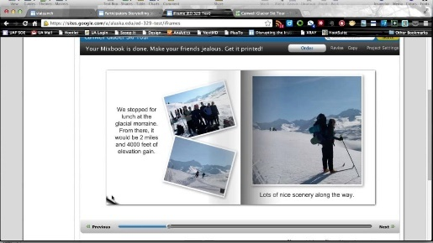 | 5 | 1 |  | 3.2.2
28 | Create a grid area using CSS as given below. Grid areas must be rectangular. The highlighted grid area spans two row and two column tracks.  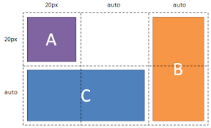 | 5 | 1 |  | 3.2.2
29 | Write a HTML code to display six different heading elements and that also includes normal paragraph text. Compare the fonts used for the various headings with the default font used for paragraph text . | 5 | 1 | 4 | 3.2.2
10 - MARKS
30 | HTML program to design web page for a bike showroom with the following specification.  - Using frameset divide the page with three frames (one row and two column).  - The top row frame should display the showroom name.  - The left column frame should display the bike brands with hyperlink.  - The right column frame should display the corresponding models with specifications, when the mobile brand hyperlink in the left column is selected. | 10 | 1 | 4 | 3.2.2
31 | Createa Personal Portfolio Webpage using html and CSS as the following sample.  It should have the menu item such as (work, about, Blog, Contact) with the hyperlink.  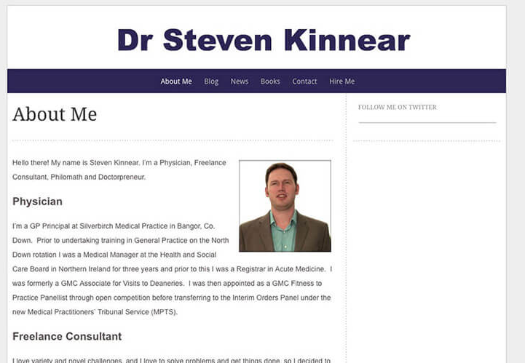 | 10 | 1 | 4 | 3.2.2
32 | create the design for the register and login forms that can be seen in the register.html and login.html pages as shown below.  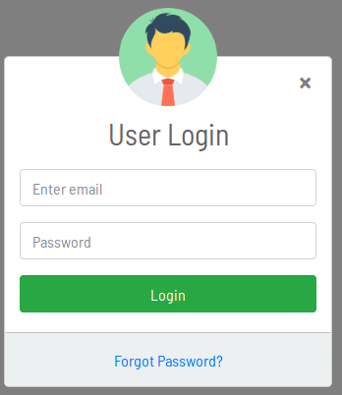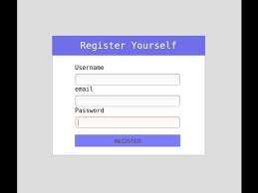 | 10 | 1 | 4 | 3.2.2
33 | Design a job application form using HTML and CSS as the sample given below.  - Form to get personal information’s  - Text box to get name.  - Option for specifying highest qualified degree  - Radio button for specifying gender  - Two buttons namely submit and cancel at the end of the form.  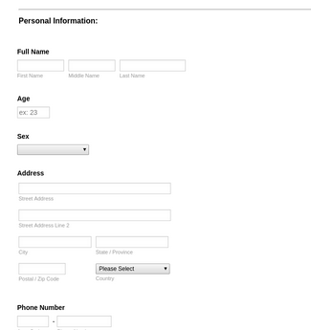 | 10 | 1 | 4 | 3.2.2
34 | Create an external style sheet to make a navigation button using a div with a link inside it. Give it a border, background and text color, and make them change when the user hover the mouse over the button. | 10 | 1 | 4 | 3.2.2
35 | Create a Navigation Menu Using CSS Image Sprite. | 10 | 1 | 4 | 3.2.2
36 | - Create webpage using embedded stylesheet, the style sheet should contain a rule that displays h1 elements in blue. Create a rule that displays all the links in blue without underlining them. When mouse hover a link, change the link’s background colour to yellow.  - Write a CSS rule that gives all h1 and h2 elements a padding of 0.5 ems, a dashed boarder style and a margin of 0.5 ems. | 10 | 1 | 4 | 3.2.2
37 | Create webpage using external style sheet to be used with the HTML reference pages, write inorder to accomplish the following  (a) Use a seashell background color for all pages (seashell is one of the SVG color keywords).  (b) Change the style of the bullets used in the short list of two hyperlinks (you choose the style).  (c) Deﬁne alternative colors for all four of the anchor pseudo-classes.  (d) Make table captions boldface, and table headers (th elements) normal weight but italicized.  (e) Use a 14-pt sans serif font for all td elements.  (f) Force text in cells that span multiple rows to be displayed at the top of the cell, rather than the default middle of the cell.  (g) On the deﬁnition pages, cause each term and its deﬁnition to be displayed in a box thathasa3-pxsolidyellowborder.The box should occupy75% of the width of the client area and should be centered. | 10 | 1 | 4 | 3.2.2

UNIT - II
Q. No. | Questions | Marks | CO | BTL | PI
1 | List any four features of JavaScript. | 2 | 2 | 1 | 1.3.1
2 | List any four javascript cookies. | 2 | 2 | 2 | 1.3.1
3 | Define a named function in JavaScript. | 2 | 2 | 4 | 1.3.1
4 | write a hello world example of JavaScript. | 2 | 2 | 4 | 1.3.1
5 | What is an argument object in javascript? | 2 | 2 | 1 | 1.3.1
6 | Write javascript code for adding new elements dynamically. | 2 | 2 | 1 | 1.3.1
7 | List any two differences of Client-side JavaScript and Server-side JavaScript. | 2 | 2 | 2 | 1.3.1
8 | What are the types of pop-up boxes available in JavaScript? | 2 | 2 | 2 | 1.3.1
9 | What is Browser Object Model? | 2 | 2 | 2 | 1.3.1
10 | Write any four attributes used in script element. | 2 | 2 | 2 | 1.3.1
11 | Write a Javascript code to create an object with four properties such as name, gender, age and eye-color using object literal. | 2 | 2 | 3 | 1.3.1
12 | What are argument objects in JavaScript & how to get the type of arguments passed to a function? | 2 | 2 | 3 | 3.2.2
13 | What is the purpose of ‘This’ operator in JavaScript? | 2 | 2 | 2 | 1.3.1
14 | How to create a function in JavaScript? | 2 | 2 | 2 | 1.3.1
15 | What are escape characters in JavaScript? | 2 | 2 | 2 | 1.3.1
16 | What is the difference between Attributes and Property in javascript? | 2 | 2 | 2 | 1.3.1
17 | How to read and write a file using JavaScript? | 2 | 2 | 2 | 1.3.1
18 | What is 'this' keyword in JavaScript? | 2 | 2 | 2 | 1.3.1
19 | What is a prompt box? | 2 | 2 | 2 | 1.3.1
20 | What is the difference between == and ===? | 2 | 2 | 2 | 1.3.1
5 - MARKS
21 | Write a Javascript program to get a string as an input and print the same in uppercase and lowercase. | 5 | 2 | 3 | 3.2.2
22 | Write a javascript program to Change the background-color of the document when the mouse clicked on the change color button. | 5 | 2 | 3 | 3.2.2
23 | Write javascript code to submit a form by clicking a link. | 5 | 2 | 3 | 3.2.2
24 | Write a JavaScript program to determine whether a given year is a leap year. | 5 | 2 | 3 | 3.2.2
25 | List the ways the javascript codes are used for accessing the HTML elements. | 5 | 2 | 4 | 3.2.2
26 | Write javascript code to get two numbers as an input and to check wheather the given numbers are equal or not equal. And prints the output as either equal or not equal. | 5 | 2 | 4 | 3.2.2
27 | Create a document to change the font-size based on the size of the window using JavaScript. | 5 | 2 | 4 | 3.2.2
28 | Create a document to get the image size (height & width) using JavaScript. | 5 | 2 | 4 | 3.2.2
29 | Write a script to create a button called “Change text colour” onclick of it, call a method that will Change the colour of the text. | 5 | 2 | 4 | 3.2.2
30 | rite a JavaScript program to convert temperatures to and from Celsius, Fahrenheit. | 5 | 2 | 4 | 3.2.2
10 - MARKS
31 | Create a html form with a submit button namely ‘change’ and a paragraph about the college. Write javascript code modify the style of the paragraph text as specified below.  - Clicking on the button named change the font, font size, and color of the paragraph text to be changed.  - To highlight the bold words of the paragraph, on mouse over a certainword. | 10 | 2 | 4 | 3.2.2
32 | Create document for an <img> element and append it to the document using JavaScript with the following specifications.  when someone clicks on the button then the <img> element created. | 10 | 2 | 4 | 3.2.2
33 | Write a script to perform the following functions.  - Reads the series of strings and outputs in a text area the string that starts with letter “b”  Reads the series of string and determine the total number of occurrences of each letter in the given string. | 10 | 2 | 4 | 3.2.2
34 | Write a script to perform the following functions.  - Reads the series of strings and outputs in a text area the string that ends with letter “ed”  Reads five-letter word from the user and produces all possible three letter words that can be derived from the five-letter word of the given string. | 10 | 2 | 4 | 3.2.2
35 | - Write a JavaScript program to count number of words in string.  - Write a JavaScript function that accepts a string as a parameter and counts the number of vowels within the string | 10 | 2 | 4 | 3.2.2
36 | Write a JavaScript program to calculate multiplication and division of two numbers  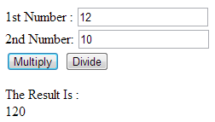 | 10 | 2 | 4 | 3.2.2
37 | - Write a script that inputs text from html from and outputs it in Uppercase and Lowercase.  - JavaScript function to check the validity of URL | 10 | 2 | 4 | 3.2.2
38 | - Javascript program to create a form with fields “Name” and “Gender”. If data in these fields are missing then the form should initiate prompts to enter the missing fields.  - JavaScript program that make the status bar gives different messages according to whether or not the mouse pointer is over the image | 10 | 2 | 4 | 3.2.2
39 | Create a javascript program that allow to drag and drop an image when the user clicks the image, it should follow the cursor until the mouse button is released. | 10 | 2 | 4 | 3.2.2
40 | Javascript program to create roll over effect for the image in the heading, | 10 | 2 | 4 | 3.2.2

UNIT -III
Q. No. | Questions | Marks | CO | BTL | PI
1 | List the common tasks performed by the servlet container. | 2 | 3 | 2 | 1.3.1
2 | List any four advantages of servlets over CGI. | 2 | 3 | 2 | 1.3.1
3 | What is Servlet Config object? | 2 | 3 | 1 | 1.3.1
4 | What is Request Dispatcher? | 2 | 3 | 2 | 1.3.1
5 | When service method of servlet gets called? | 2 | 3 | 2 | 1.3.1
6 | What is difference between PrintWriter and ServletOutputStream? | 2 | 3 | 3 | 3.1.1
7 | What is servlet listeners? | 2 | 3 | 1 | 1.3.1
8 | When destroy method of servlet gets called? | 2 | 3 | 2 | 1.3.1
9 | How does Cookies work in Servlets? | 2 | 3 | 2 | 1.3.1
10 | What are the servlet attributes and their scope? | 2 | 3 | 2 | 1.3.1
11 | What is the inter-servlet communication? | 2 | 3 | 2 | 1.3.1
12 | what is the purpose ofdoPost method of a servlet ? | 2 | 3 | 2 | 1.3.1
13 | Write Code to get the actual path of servlet in server. | 2 | 3 | 3 | 1.3.1
14 | How sendRedirect method works? | 2 | 3 | 2 | 1.3.1
15 | Mention the purpose of the servlet’s filters. | 2 | 3 | 2 | 1.3.1
16 | Mention any two advantages of using JSP over Pure Servlets. | 2 | 3 | 2 | 1.3.1
17 | What are JSP declarations and Expressions? | 2 | 3 | 1 | 1.3.1
18 | What are JSP comments? | 2 | 3 | 1 | 1.3.1
19 | What are JSP Directives? | 2 | 3 | 1 | 1.3.1
20 | What happens when buffer is set to a value “none”? | 2 | 3 | 3 | 1.3.1
5 - MARKS
21 | Describe the entire process from its creation till the destruction | 5 | 3 | 3 | 3.2.2
22 | Describe various types of servlets filters with their specifications. | 5 | 3 | 2 | 3.2.2
23 | Give the Steps to configure a central error handling page in servlets. | 5 | 3 | 3 | 3.2.2
24 | How to read and delete a cookie using servlet? | 5 | 3 | 2 | 3.2.2
25 | Describe the steps involved in JSP life cycle. | 5 | 3 | 2 | 3.2.2
26 | Name the JSP actions and Literals. | 5 | 3 | 1 | 3.2.2
27 | Describe the methods used by JSP for handling automatic form data parsing | 5 | 3 | 2 | 3.2.2
28 | What are JSP EL implicit objects? | 5 | 3 | 3 | 3.2.2
29 | How to read name of all parameters in servlet? | 5 | 3 | 3 | 3.2.2
30 | Difference Betweeninclude Directive and include Action of JSP. | 5 | 3 | 2 | 3.2.2
10 - MARKS
31 | Explain working of service method of a servlet. | 10 | 3 | 2 | 3.2.2
32 | How to read form data in servlet? | 10 | 3 | 3 | 3.2.2
33 | What are the JSP lifecycle phases? | 10 | 3 | 2 | 3.2.2
34 | Design Servlets using Java classes which service HTTP requests and implement the Servlet interface and is specially to handle HTTP requests | 10 | 3 | 4 | 3.2.2
35 | Write a Servlet to take name as request parameter from the user and display Welcome Page to the user with his name (with Get and Post HTTP methods). | 10 | 3 | 4 | 3.2.2
36 | Write a Servlet with doGet method and extract all the request information along with the inputs given by the user in text field, radio button, checkbox and drop down menu. | 10 | 3 | 4 | 3.2.2
37 | Create 2 HTML pages, one with GET method and one with POST method, with the action to the same Servlet. Handle both the requests using doGet and doPost methods. | 10 | 3 | 4 | 3.2.2
38 | Write JSP program for creating a registration form with the following fields  The form will help us to register with the application. It takes all our details and store it in a database.  which has the following fields:  - First Name  - Last Name  - Username  - Password  - Address  - Contact Number  After filling all these details, it should have submit button on click of that button all the details will be stored. | 10 | 3 | 4 | 3.2.2
39 | Create a JSP home page (like screen shot below) with SUBMIT BUTTONS in a form that have links to execute each of the JSPs/Servlets and also BUTTONS for:  - Add or Update Customer  - Browse Customers  - Browse Orders  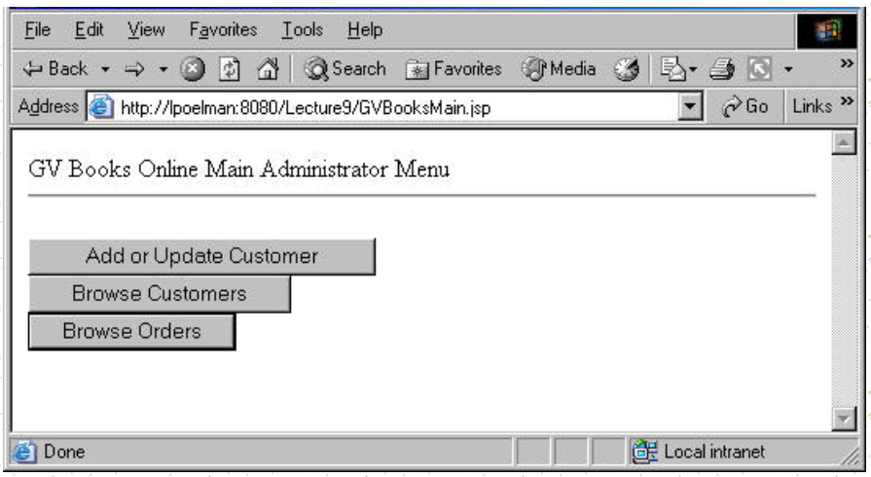 | 10 | 3 | 4 | 3.2.2
40 | Design Registration form using JSP, which contain name, username, password, address, contact number, etc.  Application registration form which take all details and store it in a database or cache.  which has the following fields:  - First Name  - Last Name  - Username  - Password  - Address  - Contact Number  - Submit button  After filling all these details, A submit button is clicked for storing all the details. | 10 | 3 | 4 | 3.2.2

UNIT - IV
Q. No. | Questions | Marks | CO | BTL | PI
1 | What is a Complex Element in XML? | 2 | 4 | 1 | 1.3.1
2 | What is the structure of XML document? | 2 | 4 | 2 | 1.3.1
3 | What is the difference between XML and HTML? | 2 | 4 | 2 | 1.3.1
4 | What is a valid XML document? | 2 | 4 | 2 | 1.3.1
5 | List out the various logical structure of an XML document. | 2 | 4 | 1 | 1.3.1
6 | What is a Processing Instruction in XML? | 2 | 4 | 1 | 1.3.1
7 | What are the ways to use namespaces in XML? | 2 | 4 | 1 | 1.3.1
8 | What is Document Type Definition? and list its types | 2 | 4 | 2 | 1.3.1
9 | List the ways to use namespaces in XML. | 2 | 4 | 1 | 1.3.1
10 | What is the correct and the most two common way to start and finish a PHP block of code? | 2 | 4 | 2 | 1.3.1
11 | How is the comparison of objects done in PHP? | 2 | 4 | 3 | 3.2.2
12 | How can PHP and Javascript interact? | 2 | 4 | 3 | 3.2.2
13 | What is needed to be able to use image function? | 2 | 4 | 3 | 3.2.2
14 | What is the use of the function 'imagetypes()'? | 2 | 4 | 1 | 1.3.1
15 | How can we connect to a MySQL database using PHP script? | 2 | 4 | 3 | 3.2.2
16 | Write php script that gets the input string and returns the string length as output. | 2 | 4 | 3 | 3.2.2
17 | How be the result set of Mysql is handled in PHP? | 2 | 4 | 3 | 3.2.2
18 | How can we access the data sent through the URL using GET method? | 2 | 4 | 3 | 3.2.2
19 | How can we define a variable accessible in functions of a PHP script? | 2 | 4 | 3 | 3.2.2
20 | List the functions of XML Parser. | 2 | 4 | 1 | 1.3.1
5 - MARKS
21 | List the attribute relevance of ElementFormDefault and AttributeFormDefaulter in the Schema. | 5 | 4 | 1 | 1.3.1
22 | Consider the three commands: PROMPT, HEAD and RCPT. indicate a correct association of these commands with FTP, HTTP and SMTP protocols and clarify where these are used. | 5 | 4 | 3 | 3.2.2
23 | Create DTD definition for the following conditions  Information for a multiple number of products coded within in one XML document.  Character data can be coded for product names (element name: product).  The product number must have a single, unique name (attribute name: partsno), and is verified as singular and unique by the XML parser.  Characters such as # and @ must not be used in price information (attribute name: price)  The default value for price (attribute name: price) is “open”. The “product” element must have a defined “partsno” attribute. | 5 | 4 | 4 | 3.2.2
24 | Write Php program to calculate the length of a string | 5 | 4 | 4 | 3.2.2
25 | Write Php program to check if the string contains a character or a word. | 5 | 4 | 3 | 3.2.2
26 | Write php program to convert a string to uppercase. | 5 | 4 | 4 | 3.2.2
27 | Write a PHP function to check whether a number is prime or not | 5 | 4 | 3 | 3.2.2
28 | Write a function to calculate the factorial of a number (a non-negative integer). The function accepts the number as an argument. | 5 | 4 | 3 | 3.2.2
29 | Write a PHP function that checks whether a string is all lowercase. | 5 | 4 | 3 | 3.2.2
30 | Write a Program in php to create following pattern using for loops:  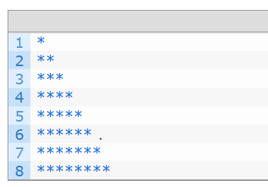 | 5 | 4 | 4 | 3.2.2
10 - MARKS
31 | creates a Php script that checks whether cookies are enabled.  creates a Php script that modifies the cookie values. | 10 | 4 | 4 | 3.2.2
32 | Write PHP script named states.php that creates a variable $states with the value “Mississippi, Alabama, Massachusetts kansas”. The script should perform the following task  - Search for word in $states that ends in xas.  - Search the word that begins with M and ends with s.  - Output the array $statesArray to the screen. | 10 | 4 | 4 | 3.2.2
33 | Write Php Program to create/Retrieve a cookie with the following condition  Cookie named “user” with the value “John”  Cookie will expire after 30 days | 10 | 4 | 4 | 3.2.2
34 | write a simple calculator program in PHP using switch case.  Operations:  - Addition  - Subtraction  - Multiplication  - Division | 10 | 4 | 4 | 3.2.2
35 | write a PHP program to calculate electricity bill using if-else conditions.  Conditions:  - For first 50 units – Rs. 3.50/unit  - For next 100 units – Rs. 4.00/unit  - For next 100 units – Rs. 5.20/unit  - For units above 250 – Rs. 6.50/unit | 10 | 4 | 4 | 3.2.2
36 | Write a PHP program using nested for loop that creates a chess board | 10 | 4 | 4 | 3.2.2
37 | Create an XML documentfor a bookstore application. The XML document will have root element and child element as following  The root element as <bookstore>. All elements in the document are contained within <bookstore>.  The root element has 4 children: <title>,<author>, <year> and <price>. | 10 | 4 | 4 | 3.2.2
38 | Consider that the owner of restaurant wants to create a web presence that shows menus from all members.  The Challenge is How can you collect menu data from a wide range of restaurants?  For the above-mentioned scenario create the following  Data structure – DTD or Schema  XML based menu for the restaurant  Use either CSS (or XSLT) to display your menu. | 10 | 4 | 4 | 3.2.2
39 | Create an XML document for plant catalogue with the hierarchy shown in the following image. Validate the XML document with the DTD of the following. use XML against DTD validation service  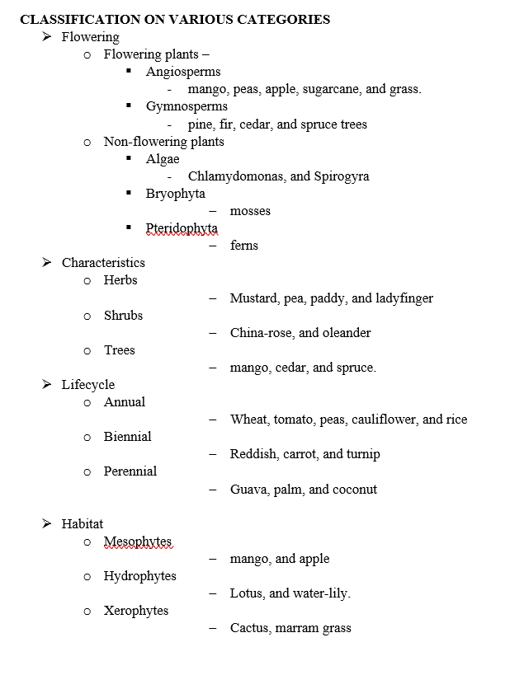 | 10 | 4 | 4 | 3.2.2

UNIT - V
Q. No. | Questions | Marks | CO | BTL | PI
1 | What is a Web Service? | 2 | 5 | 1 | 1.3.1
2 | What are the advantages of Web Services? | 2 | 5 | 2 | 1.3.1
3 | What are different types of Web Services? | 2 | 5 | 2 | 1.3.1
4 | What are advantages of SOAP Web Services? | 2 | 5 | 2 | 1.3.1
5 | What are disadvantages of SOAP Web Services? | 2 | 5 | 1 | 1.3.1
6 | What is WSDL? | 2 | 5 | 1 | 1.3.1
7 | What are different components of WSDL? | 2 | 5 | 1 | 1.3.1
8 | What is REST Web Services? | 2 | 5 | 1 | 1.3.1
9 | What are advantages of REST web services? | 2 | 5 | 1 | 1.3.1
10 | What are different HTTP Methods supported in Restful Web Services? | 2 | 5 | 1 | 1.3.1
11 | How to set different status code in HTTP response? | 2 | 5 | 2 | 1.3.1
12 | Name some frameworks in Java to implement SOAP web services. | 2 | 5 | 2 | 1.3.1
13 | What kind of security is needed for web services? | 2 | 5 | 2 | 1.3.1
14 | How would you choose between SOAP and REST web services? | 2 | 5 | 2 | 1.3.1
15 | What are different ways to test web services? | 2 | 5 | 2 | 1.3.1
5 - MARKS
16 | Compare SOAP and REST web services. | 5 | 5 | 2 | 1.3.1
17 | Describe various layers of the web service protocol stack. | 5 | 5 | 2 | 1.3.1
18 | List the significance of XML-RPC protocol. | 5 | 5 | 2 | 1.3.1
19 | Explain the term UDDI with its features | 5 | 5 | 2 | 1.3.1
20 | What do you mean by RESTful Web Services? What are the various advantages of the same? | 5 | 5 | 2 | 1.3.1
21 | Describe the core components of the HTTP request and HTTP response. | 5 | 5 | 2 | 1.3.1
22 | Write the Steps involved in designing a secure RESTful web service. | 5 | 5 | 3 | 1.3.1
23 | What are the various elements of WSDL documents? | 5 | 5 | 2 | 1.3.1
24 | Enumerate the various primary security issues of Web services. | 5 | 5 | 3 | 3.1.1
25 | Give any two success factors in implementing SOA based IT infrastructure in detail. | 5 | 5 | 3 | 3.1.1
10 - MARKS
26 | Describe the structure of WSDL document, its elements and their purposes with appropriate examples | 10 | 5 | 1 | 1.3.1
27 | Discuss about Database Driven web service | 10 | 5 | 1 | 1.3.1
28 | Create a simple Hello World JAX-WS application | 10 | 5 | 4 | 3.1.1
29 | Creating a Simple Web Service and Client with JAX-WS. | 10 | 5 | 4 | 3.1.1
30 | Create a web application that demonstrate how to use several of the Java Web services APIs together. The Coffee Break sells coffee on the Internet. Customers communicate with the Coffee Break server to order coffee online. The server uses JavaServer Faces technology as well as Java servlets, JSP pages, and JavaBeans components. When using the server, a customer enters the quantity of each coffee to order and clicks the Submit button to send the order. | 10 | 5 | 4 | 3.1.1
31 | Write in detail about various layers of the web service protocol stack. | 10 | 5 | 2 | 1.3.1
32 | Illustrate the Architecture of SOA based on web services | 10 | 5 | 3 | 3.1.1
33 | Consider a simple account-management and order processing system. The accounting personnel use a client application built with JSP to create new accounts and enter new customer orders.  Derive the process flow to implement the above scenario. | 10 | 5 | 4 | 3.1.1
34 | Enlist few syntax rules applicable for SOAP message. | 10 | 5 | 4 | 3.1.1

